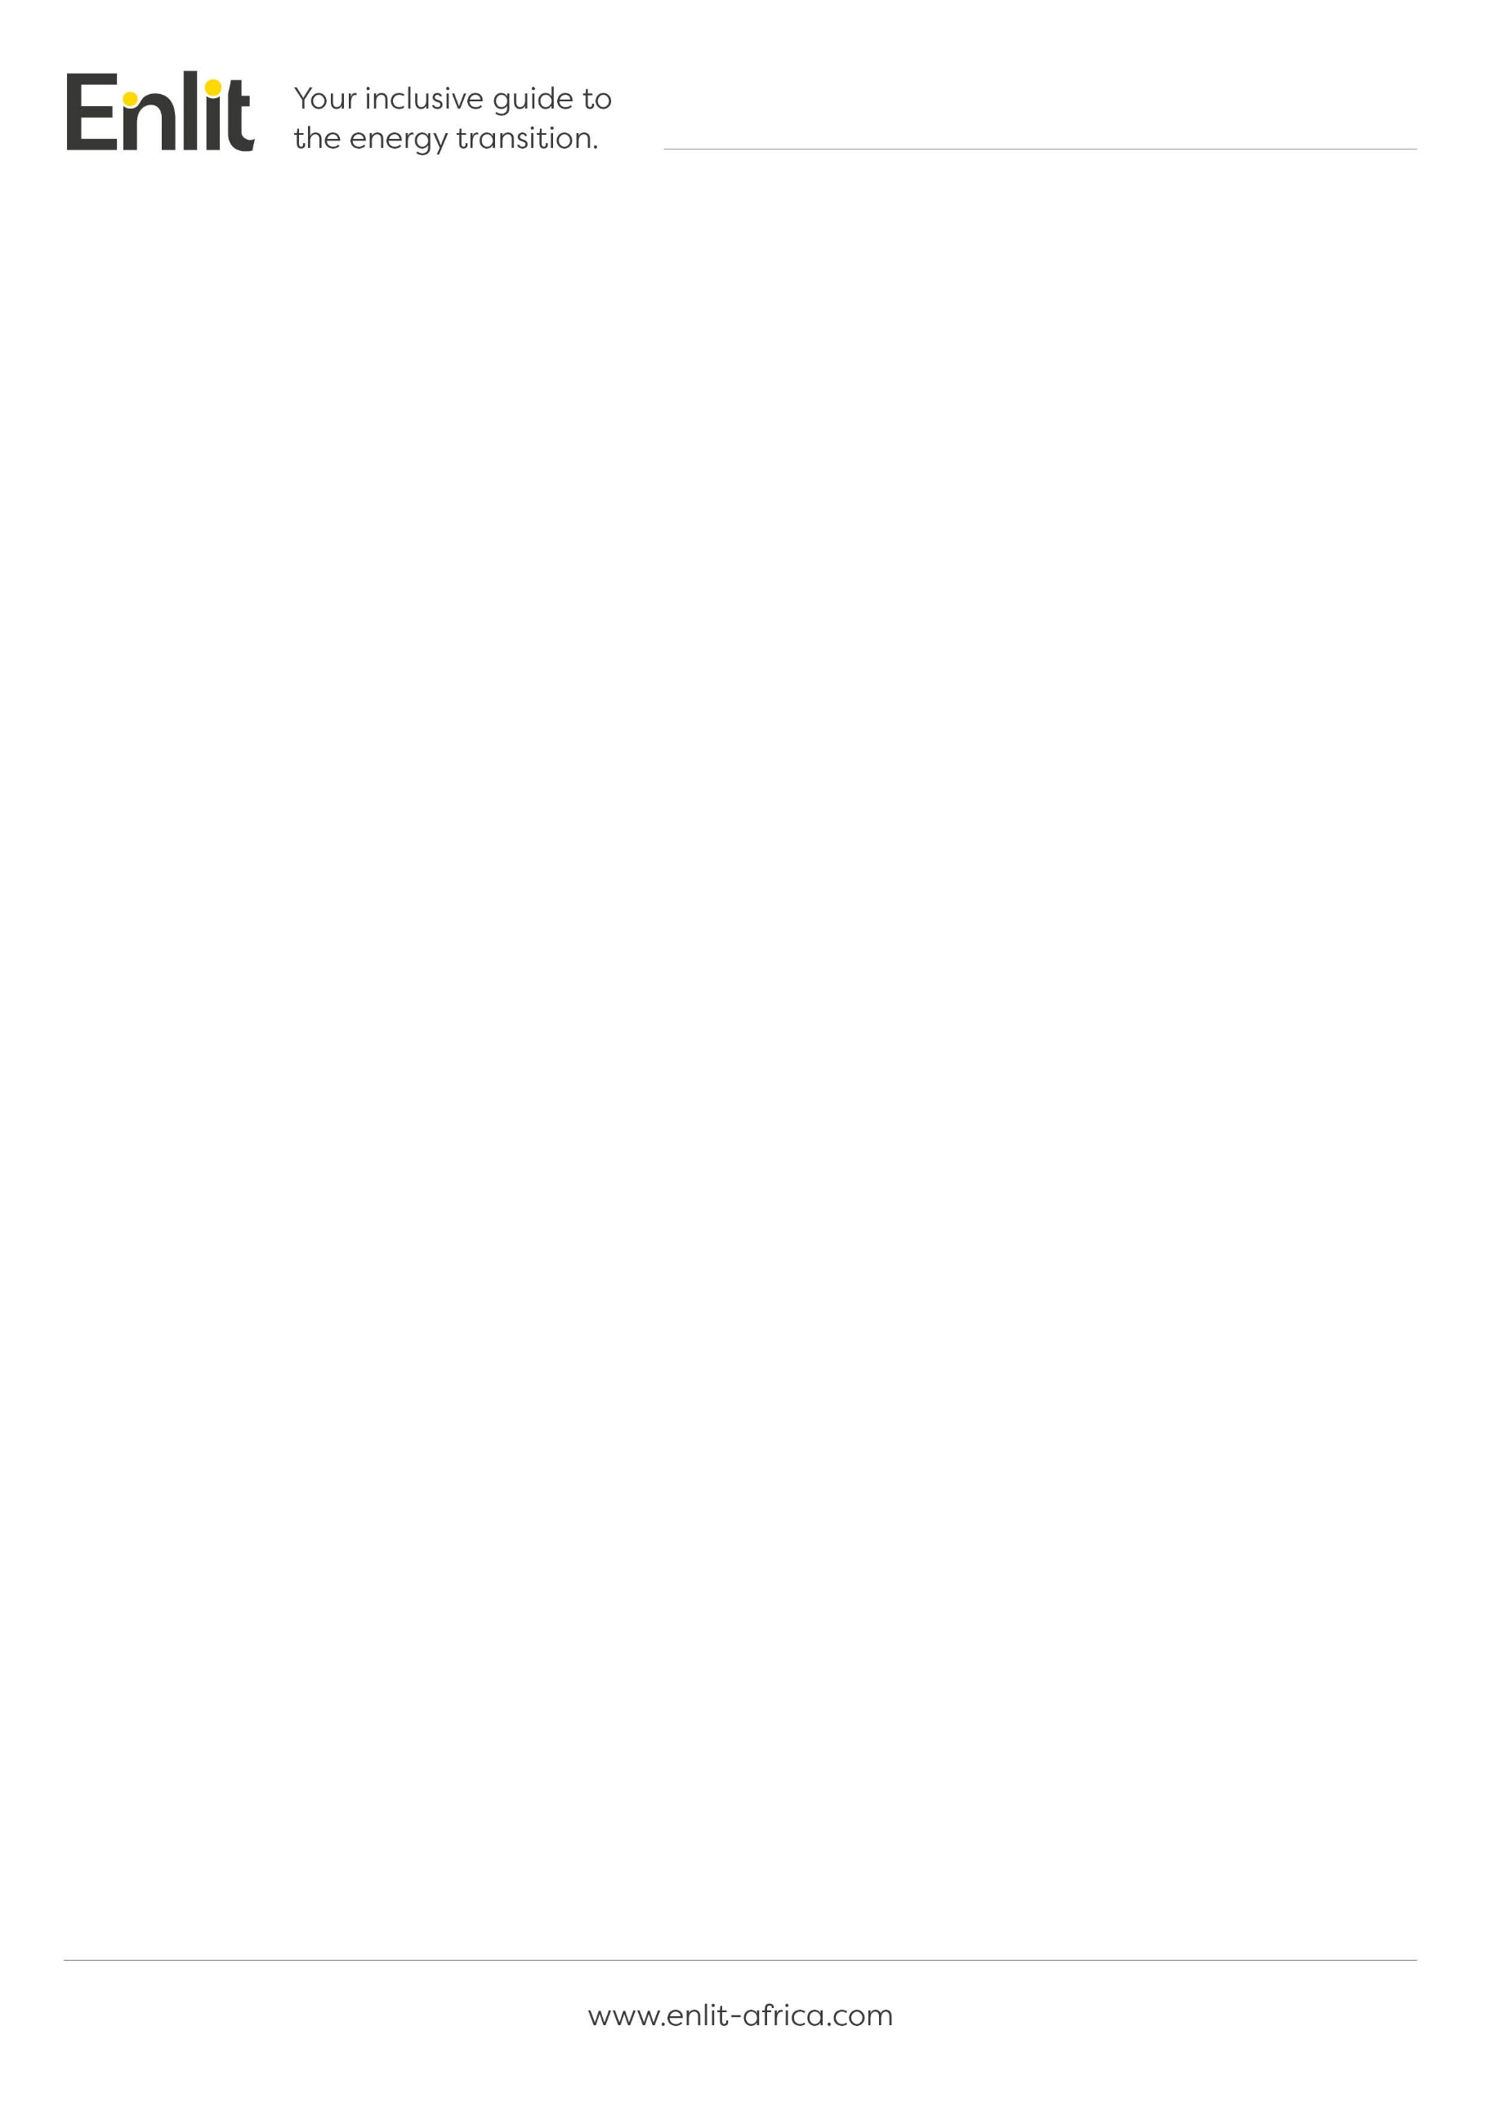
Template for the Submission of Abstracts
Enlit Africa is the new unifying brand for African Utility Week and POWERGEN Africa and continues to be Africa’s premier meeting place for the entire power, energy and water value chain.
It is a community that for 365 days a year will collaborate and innovate on an interactive end-to-end platform to solve the most pressing energy-related issues for the continent.
Enlit Africa will bring together our community in a blended live and digital event for three days in Cape Town, that seeks to meet and inspire each other and develop actions into a working plan for the coming year.
To join this prestigious event as a profiled speaker, you are invited to submit practical, thought-provoking, innovative, futuristic, and problem-solving abstracts.
Title, Name & Surname | Click here to enter text.
Job Title | Click here to enter text.
Company name | Click here to enter text.
Country | Click here to enter text.
Physical or postal address | Click here to enter text.
Email address | Click here to enter text.
Telephone number | Click here to enter text.
Mobile number | Click here to enter text.
PA’s email address | Click here to enter text.

Abstract
Title of the presentation | Click here to enter text.
Abstract content | Click here to enter text.  (Between 200 - 500 words)

Additional information
Which sector/s is the abstract most suitable for?

☐ Generation (from clean power to traditional base load)
☐ Transmission & Distribution
☐ Electricity Metering
☐ Alternative technologies

☐ Commercial and Industrial
☐ Embedded Generation
☐ Energy Storage
☐ Finance and Investment
☐ Other

Which of the following best describes the content of your abstract?
☐ Strategic
☐ Technical
☐ Case Study
☐ Product Demo

List three learning objectives the audience will take home:
Click here to enter text.
Click here to enter text.
Click here to enter text.

Photograph:
Plus attach a high resolution photograph with your submission.
Speaker biography [100 words or less]:
Click here to enter text.

(50 – 100 words. We will use only the first 100 words.)

Short statement about the current challenges and possible solutions in Africa’s energy/water sectors:
For use in the event marketing campaign and press releases

Click here to enter text.

Basic Abstract Guidelines
- Speakers accept responsibility for their own travel and accommodation arrangements and related expenses to attend the conference,
- Confirmed speakers will be provided with a complimentary delegate conference pass,
- The complimentary conference pass includes teas, lunches and networking events (excluding the site visits and gala dinner that are separately bookable),
- The abstract must not be more than 500 words in length,
- The biography must not be more than 100 words in length,
- Submitted abstracts must be in English,
- Only non-commercial abstracts will be accepted and strictly no vendor sales pitches,
- All abstracts will be evaluated by industry specific Advisory Board members and acceptance determined on merit
- Enlit Africa is an inactive platform of thought leadership. If the abstract is accepted the format of your participation could be in the form of a roundtable facilitator, panellist, case study presenter, demo speaker, chairperson or technical PPT presenter.

Please submit your abstract to Claire Volkwyn at claire.volkwyn@wearevuka.com

THANK YOU

